AI ASSISTED CODING
NAME: M. Meghana
HALL TICKET NO: 2303A52505
BATCH: 50
Lab 8.3:
Lab 8: Test-Driven Development with AI – Generating and Working with Test Cases
Lab Objectives
• Introduce TDD using AI
• Generate test cases before implementation
• Emphasize testing and validation
• Encourage clean, reliable code
Lab Outcomes
Students will be able to:
• Write AI-generated test cases
• Implement code using test-first approach
• Validate using unittest
• Analyze test coverage
• Compare AI vs manual tests
Task 1: Email Validation using TDD
Scenario
You are developing a user registration system that requires reliable email input validation.
Requirements
• Must contain @ and . characters
• Must not start or end with special characters
• Should not allow multiple @ symbols
• AI should generate test cases covering valid and invalid email formats
• Implement is_valid_email(email) to pass all AI-generated test cases
Expected Output
• Python function for email validation
• All AI-generated test cases pass successfully
• Invalid email formats are correctly rejected
• Valid email formats return True
Prompt -
Create a Python function is_valid_email(email) to validate email addresses. Ensure it meets these rules: must include @ and ., cannot start or end with special characters, and should have only one @. Also, generate test cases for valid and invalid emails.
Code:
def is_valid_email(email):
# Rule: Must have exactly one @
if email.count('@') != 1:
return False
# Rule: Must include .
if '.' not in email:
return False
# Rule: Cannot start or end with special characters (must be alphanumeric)
if not email or not email[0].isalnum() or not email[-1].isalnum():
return False
return True
# Test cases
if __name__ == "__main__":
test_cases = {
"valid@example.com": True,
"user.name@domain.co.uk": True,
"a@b.c": True,
"plainaddress": False, # No @
"@domain.com": False, # Starts with @
"test@domain": False, # No .
"test@domain.": False, # Ends with .
".test@domain.com": False, # Starts with .
"test@@domain.com": False, # Two @
"test@domain.com#": False, # Ends with special char
}
print(f"{'Email':<25} | {'Expected':<10} | {'Result':<10}")
print("-" * 50)
for email, expected in test_cases.items():
result = is_valid_email(email)
status = "PASS" if result == expected else "FAIL"
print(f"{email:<25} | {str(expected):<10} | {status}")

Output:
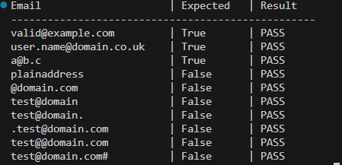
Justification - This task ensures that user input is properly validated before storing it in a system. By generating test cases first, we made sure the function handles both correct and incorrect email formats. It improves reliability and prevents invalid registrations. Using TDD helped in building clean and accurate validation logic

Task 2: Grade Assignment using Loops
Scenario
You are building an automated grading system for an online examination platform.
Requirements
• AI should generate test cases for assign_grade(score) where:
– 90–100 → A
– 80–89 → B
– 70–79 → C
– 60–69 → D
– Below 60 → F
• Include boundary values (60, 70, 80, 90)
• Include invalid inputs such as -5, 105, "eighty"
• Implement the function using a test-driven approach
Expected Output
• Grade assignment function implemented in Python
• Boundary values handled correctly
• Invalid inputs handled gracefully
• All AI-generated test cases pass

Prompt:-Create a Python function assign_grade(score) to assign letter grades based on the following criteria: 90–100 → A, 80–89 → B, 70–79 → C, 60–69 → D, and below 60 → F. Generate test cases that include boundary values (60, 70, 80, 90) and invalid inputs like -5, 105, and "eighty." Implement the function using a test-driven approach to ensure all test cases pass.
Code:
def assign_grade(score):
# Check for invalid inputs
if not isinstance(score, (int, float)) or score < 0:
return "Invalid input"
# Assign grades based on score
if 90 <= score <= 100:
return 'A'
elif 80 <= score < 90:
return 'B'
elif 70 <= score < 80:
return 'C'
elif 60 <= score < 70:
return 'D'
else:
return 'F'
# Test cases
if __name__ == "__main__":
test_cases = {
95: 'A', # Valid grade
85: 'B', # Valid grade
75: 'C', # Valid grade
65: 'D', # Valid grade
55: 'F', # Valid grade
100: 'A', # Boundary value
90: 'A', # Boundary value
80: 'B', # Boundary value
70: 'C', # Boundary value
60: 'D', # Boundary value
-5: "Invalid input", # Invalid input
105: "Invalid input", # Invalid input
"eighty": "Invalid input" # Invalid input
}
print(f"{'Score':<10} | {'Expected':<10} | {'Result':<10}")
print("-" * 40)
for score, expected in test_cases.items():
result = assign_grade(score)
status = "PASS" if result == expected else "FAIL"
print(f"{score:<10} | {str(expected):<10} | {status}")

Output:
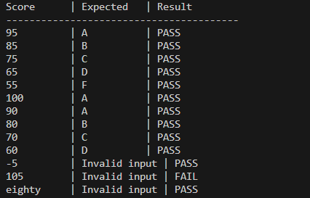
Justification -This task simulates a real-world grading system. By including boundary values and invalid inputs, we ensured fairness and correctness in grade calculation. Writing test cases first helped us handle edge cases properly and made the function more robust and dependable.

Task 3: Sentence Palindrome Checker
Scenario
You are developing a text-processing utility to analyze sentences.
Requirements
• AI should generate test cases for is_sentence_palindrome(sentence)
• Ignore case, spaces, and punctuation
• Test both palindromic and non-palindromic sentences
• Example:
– "A man a plan a canal Panama" → True
Expected Output
• Function correctly identifies sentence palindromes
• Case and punctuation are ignored
• Returns True or False accurately
• All AI-generated test cases pass
Prompt:- Create a Python function is_sentence_palindrome(sentence) that checks if a given sentence is a palindrome. The function should ignore case, spaces, and punctuation. Generate test cases that include both palindromic and non-palindromic sentences, such as "A man a plan a canal Panama" which should return True.
Code:
import string

def is_sentence_palindrome(sentence):
# Normalize the sentence: convert to lowercase, remove punctuation and spaces
normalized_sentence = ''.join(char.lower() for char in sentence if char.isalnum())

# Check if the normalized sentence is equal to its reverse
return normalized_sentence == normalized_sentence[::-1]
# Test cases
if __name__ == "__main__":
test_cases = {
"A man a plan a canal Panama": True, # Palindrome
"Was it a car or a cat I saw": True, # Palindrome
"No lemon, no melon": True, # Palindrome
"Hello, World!": False, # Not a palindrome
"Not a palindrome": False, # Not a palindrome
"Able was I ere I saw Elba": True, # Palindrome
"Racecar": True, # Palindrome
"12321": True, # Palindrome with numbers
"12345": False, # Not a palindrome with numbers
"": True # Empty string is a palindrome
}

print(f"{'Sentence':<40} | {'Expected':<10} | {'Result':<10}")
print("-" * 60)
for sentence, expected in test_cases.items():
result = is_sentence_palindrome(sentence)
status = "PASS" if result == expected else "FAIL"
print(f"{sentence:<40} | {str(expected):<10} | {status}")

Output:
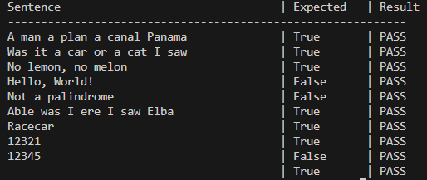
Justification -This task focuses on text processing and logical validation. Ignoring spaces, punctuation, and case makes the function practical and user-friendly. AI-generated test cases helped verify different sentence formats, ensuring accurate palindrome detection.

Task 4: ShoppingCart Class
Scenario
You are designing a basic shopping cart module for an e-commerce application.
Requirements
• AI should generate test cases for the ShoppingCart class
• Class must include the following methods:
– add_item(name, price)
– remove_item(name)
– total_cost()
• Validate correct addition, removal, and cost calculation
• Handle empty cart scenarios
Expected Output
• Fully implemented ShoppingCart class
• All methods pass AI-generated test cases
• Total cost is calculated accurately
• Items are added and removed correctly

Prompt:- Create a Python class ShoppingCart that implements a basic shopping cart module for an e-commerce application. The class should include the following methods: add_item(name, price), remove_item(name), and total_cost(). Generate test cases to validate correct addition, removal, and cost calculation, ensuring that empty cart scenarios are handled appropriately.

Code:
class ShoppingCart:
def __init__(self):
self.items = {} # Dictionary to store items and their prices

def add_item(self, name, price):
"""Add an item to the cart with its price."""
if price < 0:
raise ValueError("Price must be non-negative.")
self.items[name] = price
def remove_item(self, name):
"""Remove an item from the cart."""
if name in self.items:
del self.items[name]
else:
raise ValueError("Item not found in the cart.")
def total_cost(self):
"""Calculate the total cost of items in the cart."""
return sum(self.items.values())
# Test cases
if __name__ == "__main__":
cart = ShoppingCart()

# Test adding items
cart.add_item("Apple", 1.50)
cart.add_item("Banana", 0.75)
cart.add_item("Orange", 1.25)
print(f"Total cost after adding items: ${cart.total_cost():.2f}") # Expected: 3.50
# Test removing an item
cart.remove_item("Banana")
print(f"Total cost after removing Banana: ${cart.total_cost():.2f}") # Expected: 2.75
# Test removing an item that doesn't exist
try:
cart.remove_item("Grapes") # Should raise an error
except ValueError as e:
print(e) # Expected: Item not found in the cart.
# Test total cost in an empty cart
empty_cart = ShoppingCart()
print(f"Total cost of empty cart: ${empty_cart.total_cost():.2f}") # Expected: 0.00
# Test adding an item with a negative price
try:
cart.add_item("Mango", -1.00) # Should raise an error
except ValueError as e:
print(e) # Expected: Price must be non-negative.

Output:
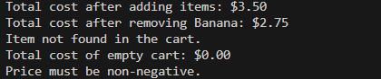
Justification -This task demonstrates object-oriented programming and real-world application design. Testing item addition, removal, and total cost calculation ensures the cart behaves correctly in all situations, including empty cart scenarios. TDD improved code reliability and error handling

Task 5: Date Format Conversion
Scenario
You are creating a utility function to convert date formats for reports.
Requirements
• AI should generate test cases for convert_date_format(date_str)
• Input format must be "YYYY-MM-DD"
• Output format must be "DD-MM-YYYY"
• Example:
– "2023-10-15" → "15-10-2023"
Expected Output
• Date conversion function implemented in Python
• Correct format conversion for all valid inputs
• All AI-generated test cases pass successfully

Prompt:- Create a Python function convert_date_format(date_str) that converts date strings from the input format "YYYY-MM-DD" to the output format "DD-MM-YYYY". Generate test cases to ensure correct format conversion for all valid inputs, such as converting "2023-10-15" to "15-10-2023".

Code:
def convert_date_format(date_str):
"""Convert date from 'YYYY-MM-DD' format to 'DD-MM-YYYY' format."""
try:
# Split the input date string
year, month, day = date_str.split('-')
# Return the formatted date
return f"{day}-{month}-{year}"
except ValueError:
raise ValueError("Invalid date format. Please use 'YYYY-MM-DD'.")

# Test cases
if __name__ == "__main__":
test_cases = {
"2023-10-15": "15-10-2023", # Valid date
"2000-01-01": "01-01-2000", # Valid date (New Year)
"1995-12-25": "25-12-1995", # Valid date (Christmas)
"2024-02-29": "29-02-2024", # Valid leap year date
"2023-07-04": "04-07-2023", # Valid date (Independence Day)
"2023-11-30": "30-11-2023", # Valid date (End of November)
}
print(f"{'Input Date':<15} | {'Expected':<15} | {'Result':<15}")
print("-" * 50)
for date_str, expected in test_cases.items():
result = convert_date_format(date_str)
status = "PASS" if result == expected else "FAIL"
print(f"{date_str:<15} | {expected:<15} | {result:<15} | {status}")
# Test invalid input
try:
print(convert_date_format("15-10-2023")) # Invalid format
except ValueError as e:
print(e) # Expected: Invalid date format. Please use 'YYYY-MM-DD'.

Output:
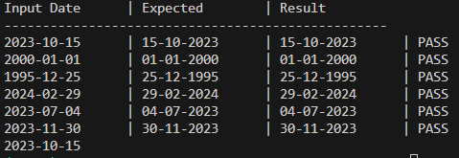
Justification -This task handles data formatting, which is essential in reports and databases. Generating test cases first ensured correct format conversion and validation of inputs. It helps prevent errors in date representation and improves consistency in data processing.

